**FIREWALL EXPLORATION LAB SEED 2.0**

Environment Setup 3

1. Creating a Docker Container: 3

2. Configure Docker on host A: 3

3. Setting up Docker for the seed router: 4

4. Configure Docker on host 1, 2 and 3: 4

Task 1: Compile the Program 5

Task 1.A: Working with kernel modules: 5

Task 1.B: Code changes: 6

Subtask 1: Block packets: 7

Subtask 2: Additional hooks: 9

Subtask 3: Network Filtering: 13

Task 2: Configuring IP Tables 17

Task 2.A: Seed router IP Tables: 17

Task 2.B: Internal network protection: 18

Task 2.C: Internal Host Communication: 19

Task 3: Experiments 20

Task 3.A: ICMP, UDP, and TCP Experiments: 20

Task 3.B: Configure IPTables: 22

Task 4: Traffic Limiting 23

Task 5: Load Balancing 24

# Environment Setup

This phase lays the foundation for the exploration lab by setting up the necessary Docker containers. Each container corresponds to a different network entity, such as host A, seed router, host 1, host 2, and host 3. This step ensures a well-defined and isolated environment for subsequent tasks and experiments.

## Creating a Docker Container:

Use dc build and dc up in Seed to build and set up Docker containers for routers, host 1, host 2, and host 3.

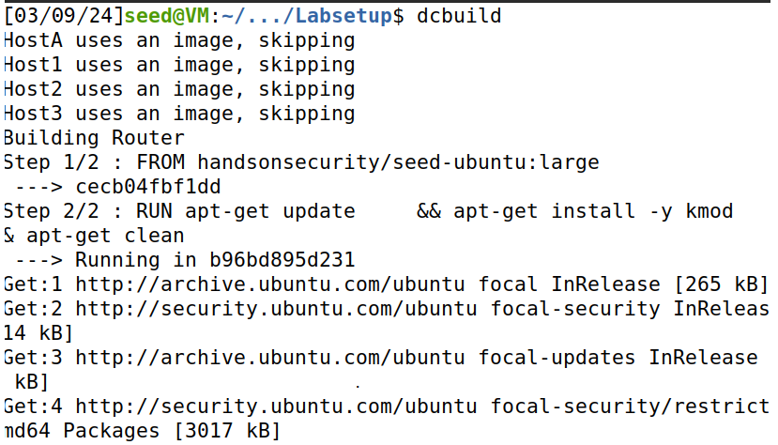

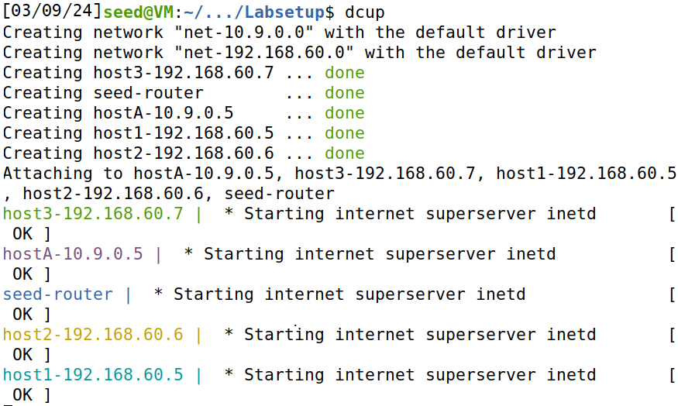

## Configure Docker on host A:

Configure Docker on host A. By using dockps and docksh we can configure the host a.

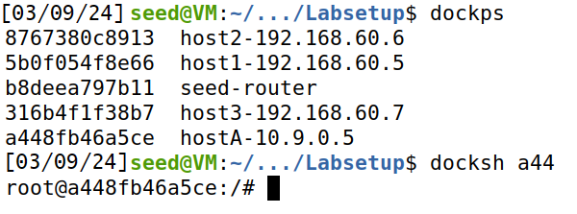

## Setting up Docker for the seed router:

Just like host a we set up Docker for the seed router. We also note its IP address.

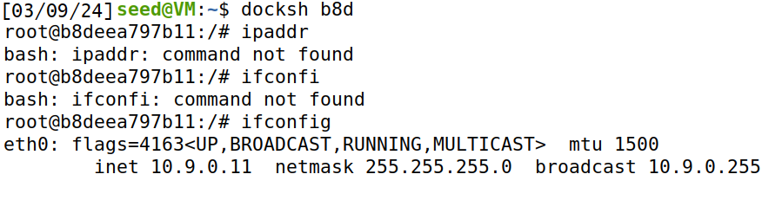

## Configure Docker on host 1, 2 and 3:

Configure Docker on host 1.

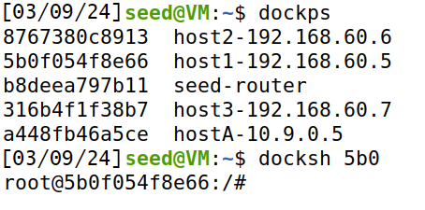

Set up Docker on host 2 .

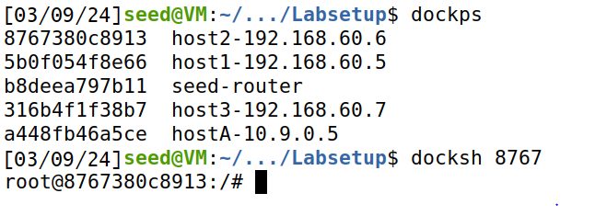

Now for host 3.

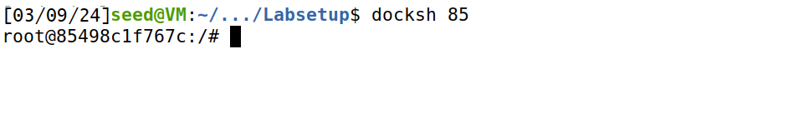

# Task 1: Compile the Program

The first task is to compile the kernel module program. The first sub task, task 1.A, involves loading and editing kernel modules using commands such as ``insmod'' and ``modinfo''. Task 1.B extends the study by modifying the specified code, introducing additional hooks, and implementing network filtering mechanisms in subsequent sub tasks.

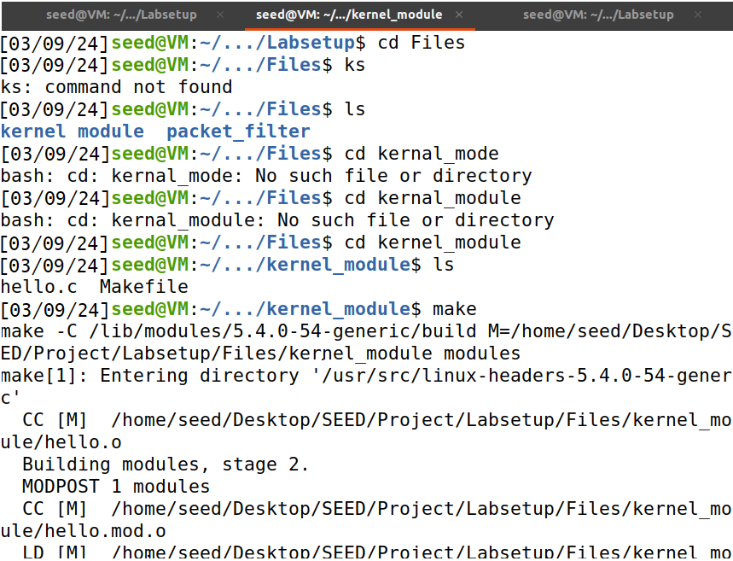

## Task 1.A: Working with kernel modules:

1. I checked “dmesg” for kernel module messages on wait when I ran “sudo insmod hello.ko”. in return I received the following,

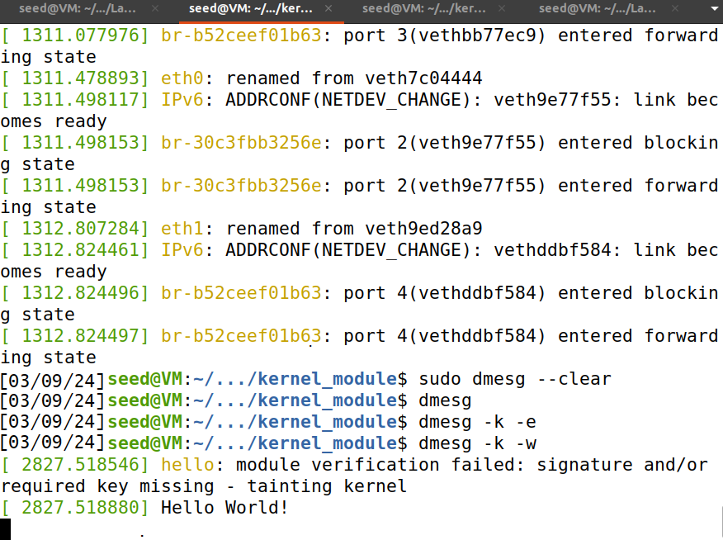

1. After that I used a command to list the modules and I removed the hello module.

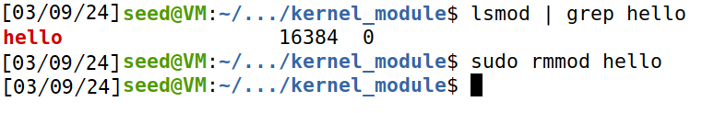

As a result I received the bye message on the terminal that I kept on wait for messages.

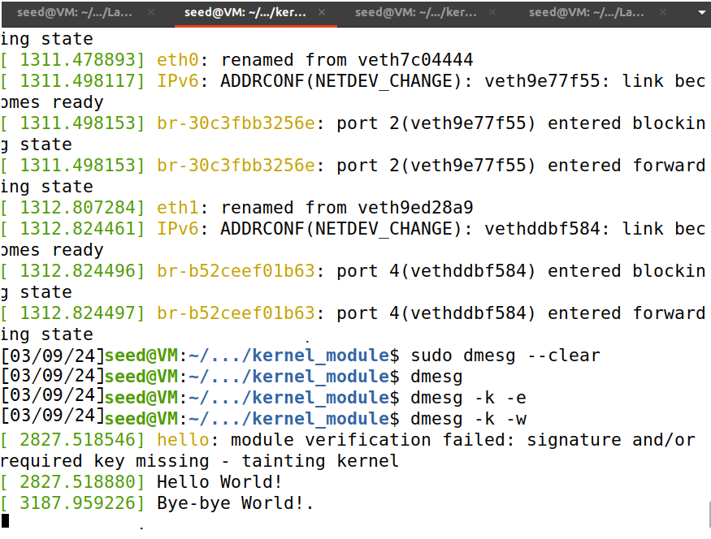

1. Use modinfo to display information about module hello.ko.

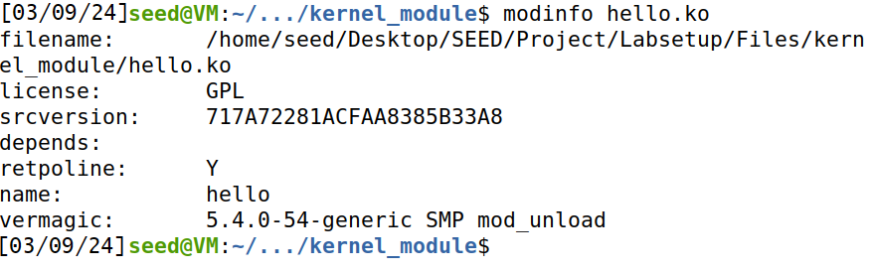

## Task 1.B: Code changes:

1. I made the specified changes with the code given with lab along with the comments.

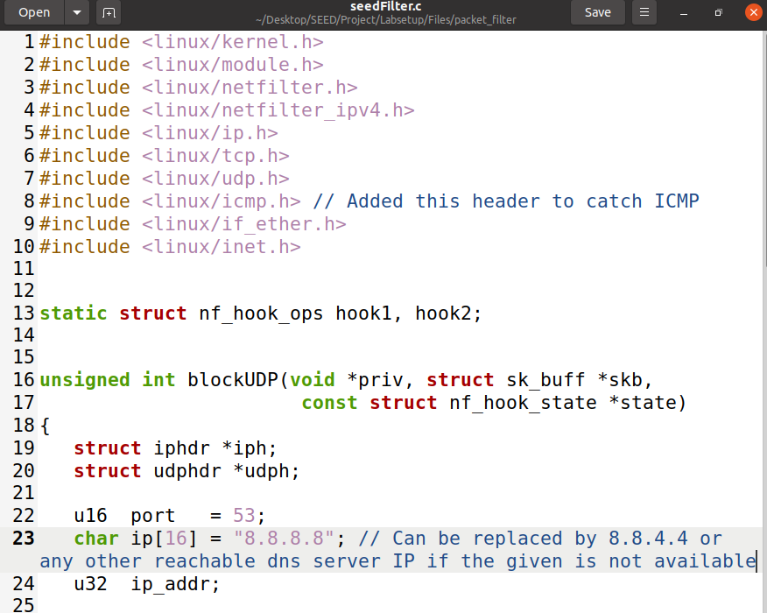

### Subtask 1: Block packets:

1. Here as you will see that DNS server is available at 8.8.8.8. so we can ping it and dig it.

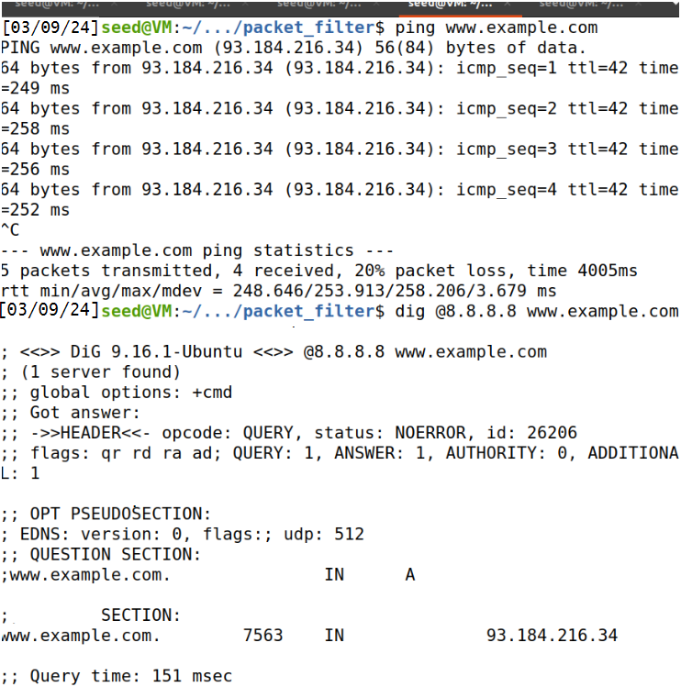

1. I will now compile the modified kernel module and then I will run it to test packet capture. I will also ensure if it is working properly.

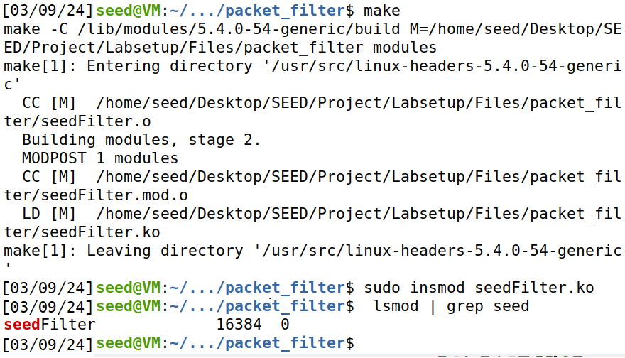

1. Now I can see on the terminal if the packets are being captured or not. And as we can see the packets are being captured.

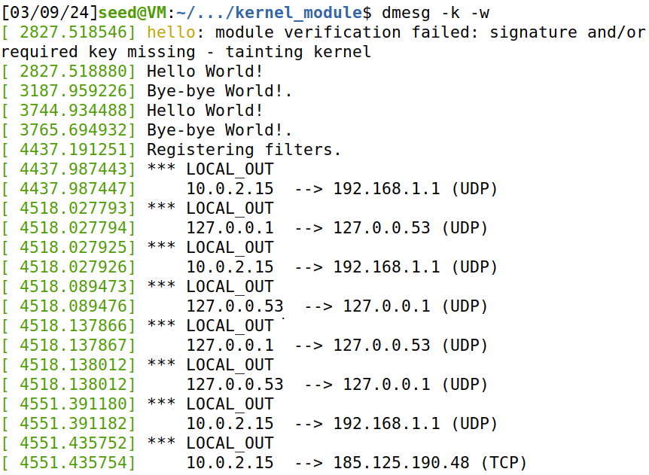

1. But when I try to dig again I can see that the packets are being dropped and the digging has timed out.

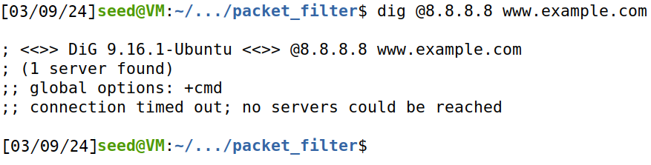

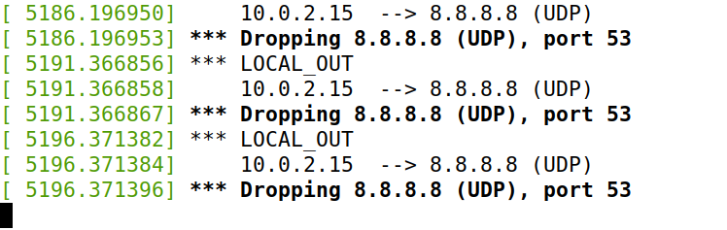

it means that packets are successfully blocked.

### Subtask 2: Additional hooks:

1. Now I again made changes to the original program given for this task. I added additional hooks to the program as following,

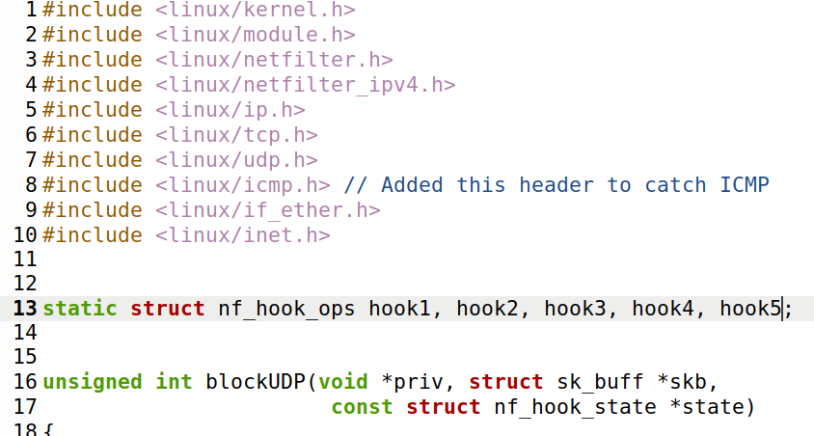

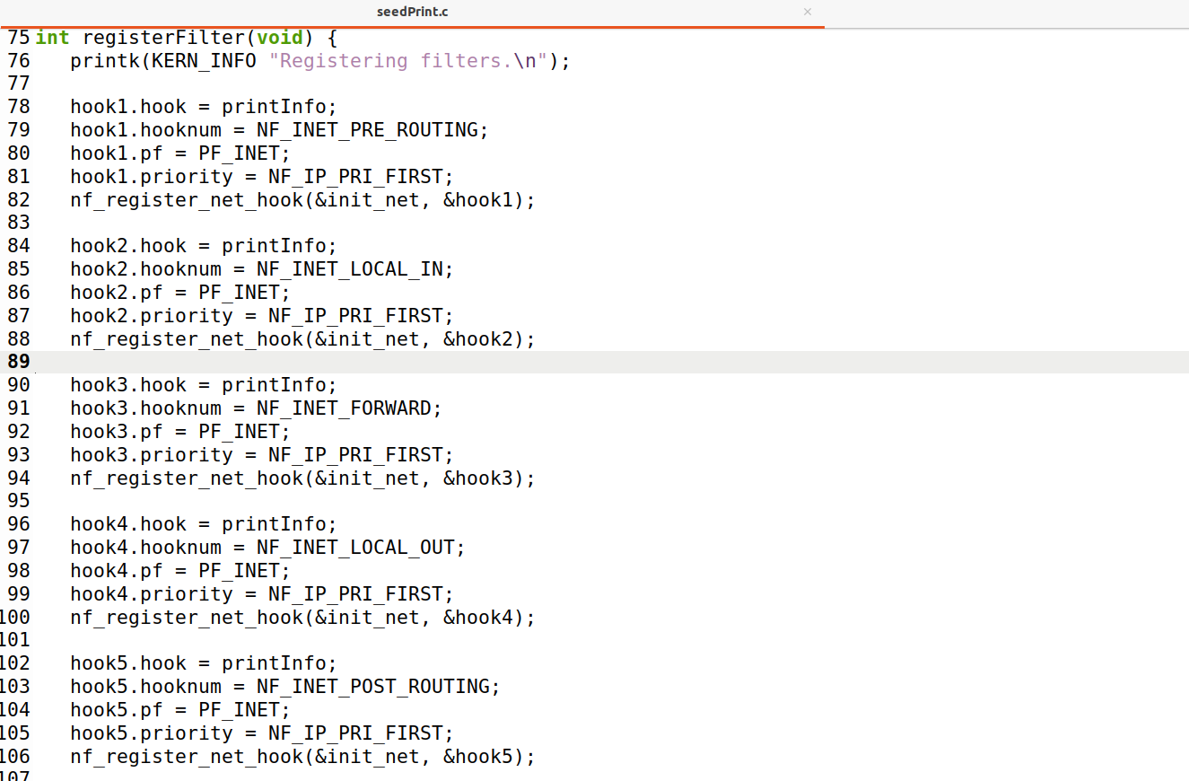

As seen above I also added the filters to be registered. Then I also added the function for the unregisteration of the filters.

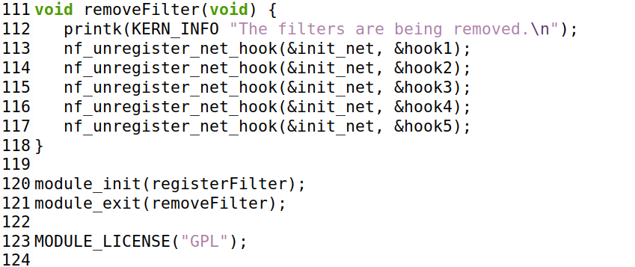

1. Then we configured the makefile accordingly as following

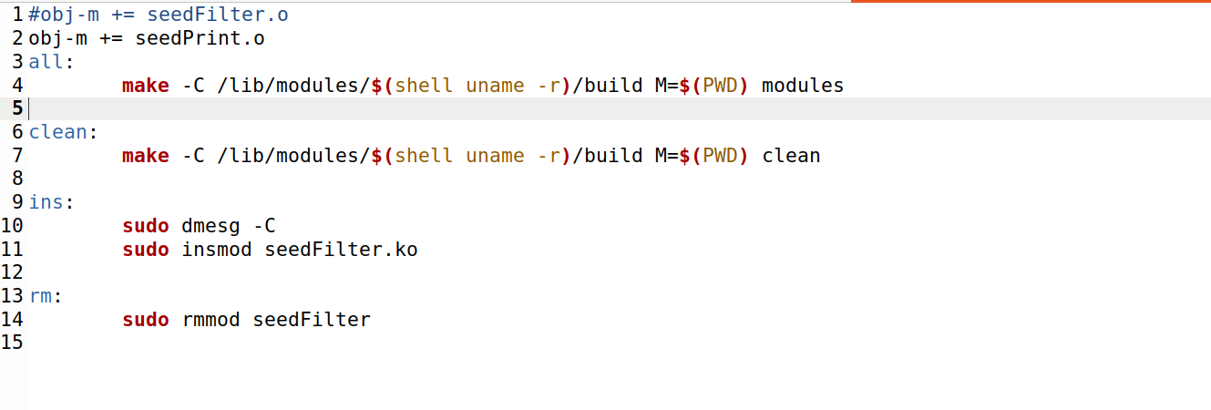

1. Now we will compile the code and execute the code to test the hook.

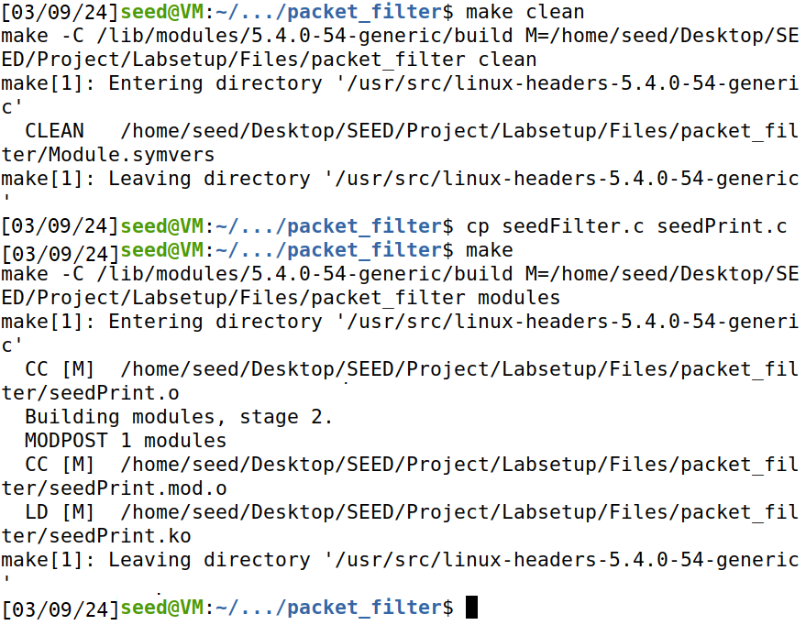

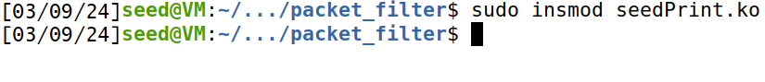

As we can see below hooks are working properly.

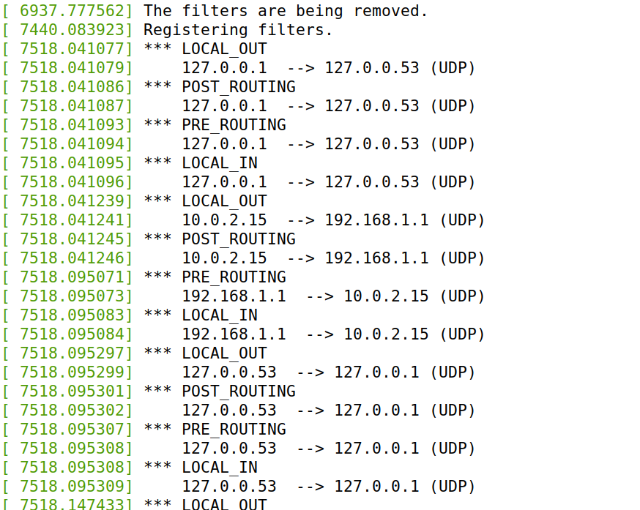

1. In this step we will try on our target and we will check if it is working or not.

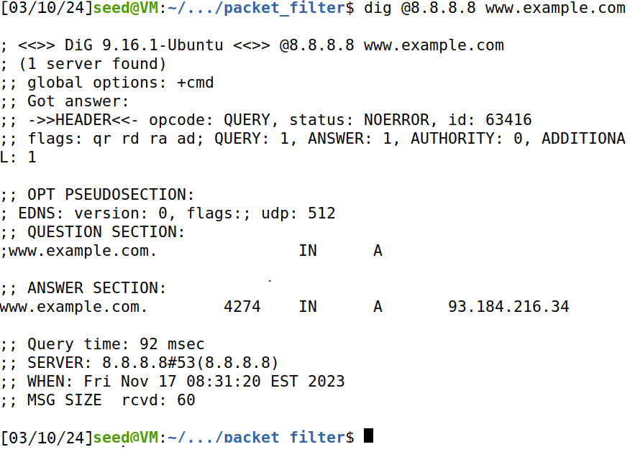

LOCAL_OUT is the spot from where we dig the target then POST_ROUTING is when the packet is going from our machine to dns server then PRE_ROUTING is when the packet comes back from the server to the machine and then we get a LOCAL_IN. There is no FORWARD as it is on the loader but basically it is useful for forwarding the packets to another destination.

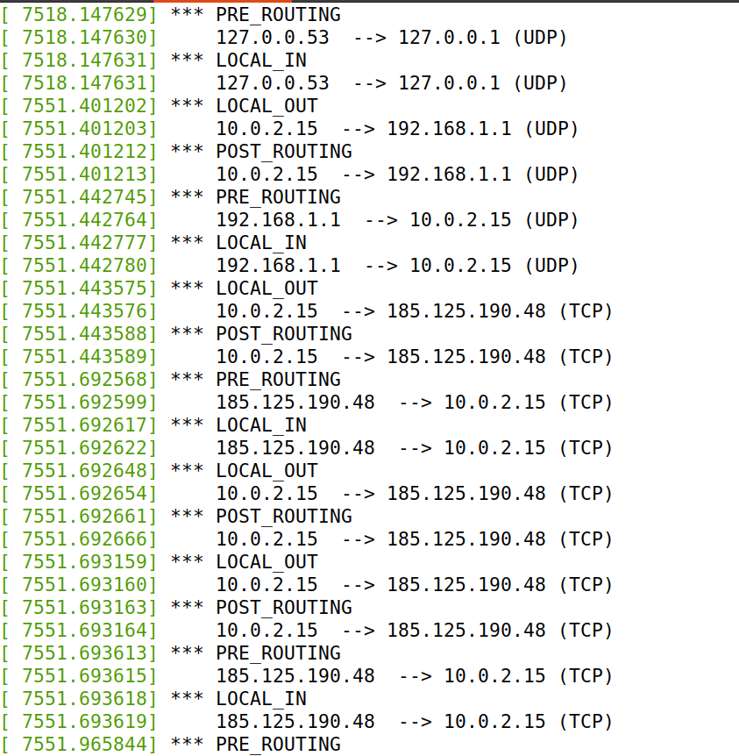

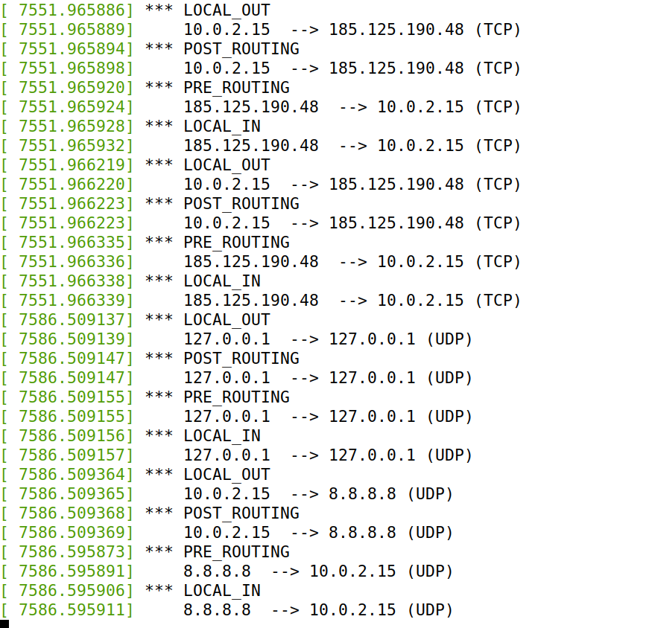

1. In this step I remove the module and we can see that the filters will be removed as well.



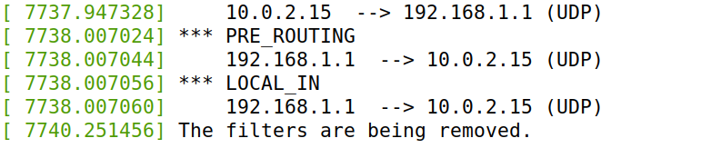

### Subtask 3: Network Filtering:

1. Ping and Telnet from host A to seed VM in which both were successful.

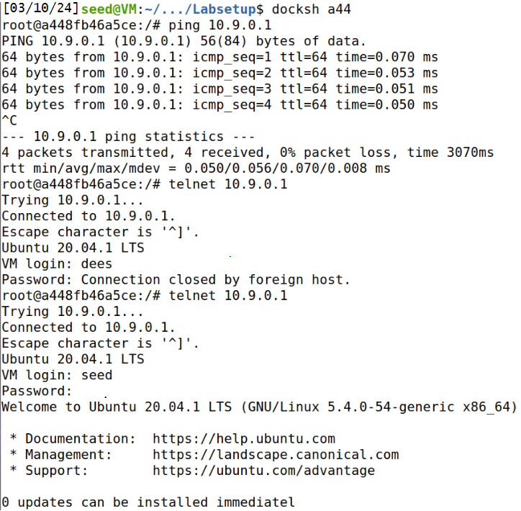

1. Modify code using hooks and filters for network filtering and functions for telnet and ping blocking.

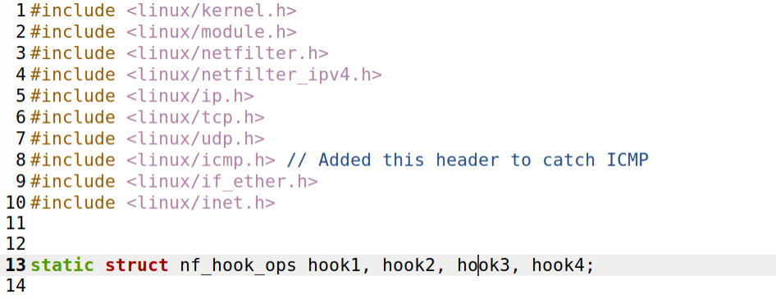

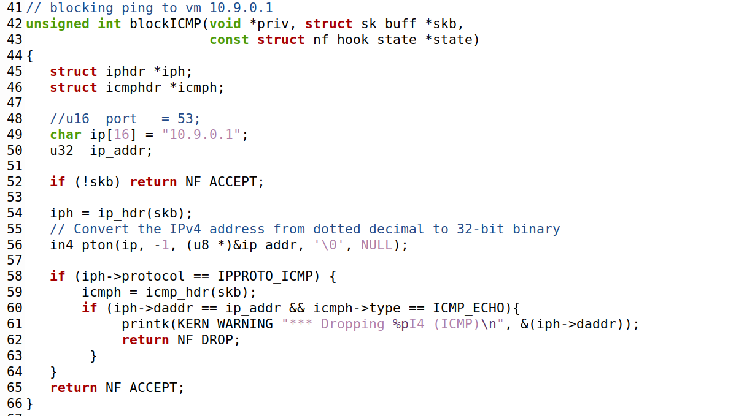

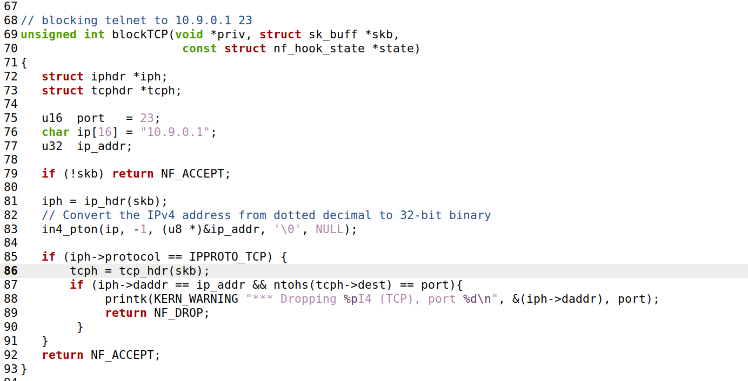

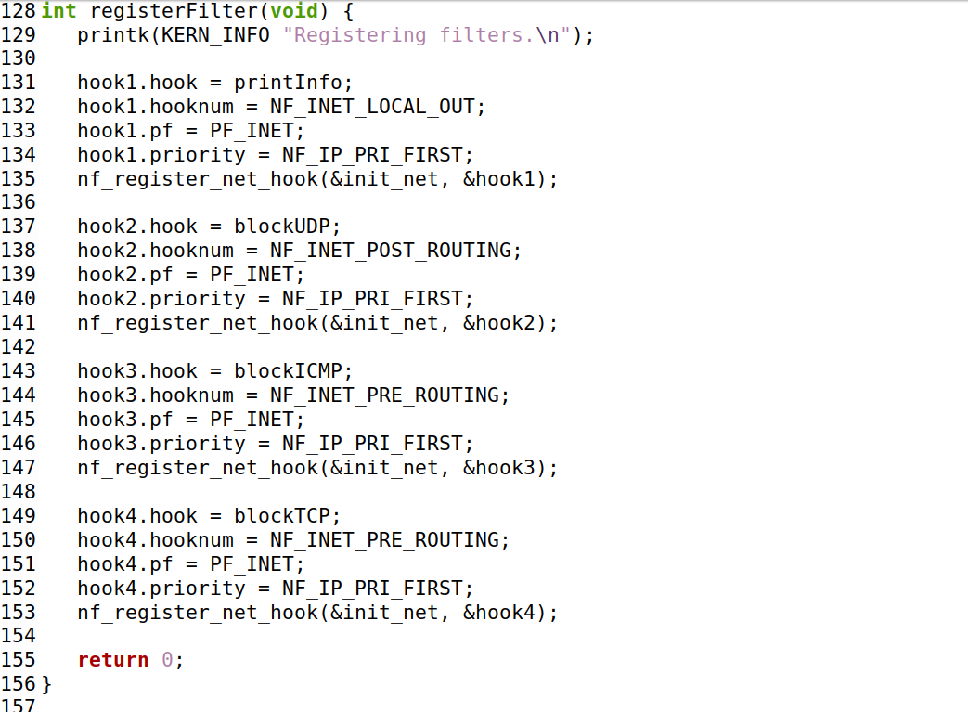

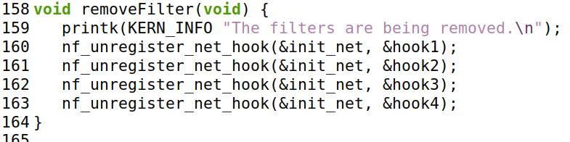

1. Now we change the makefile.

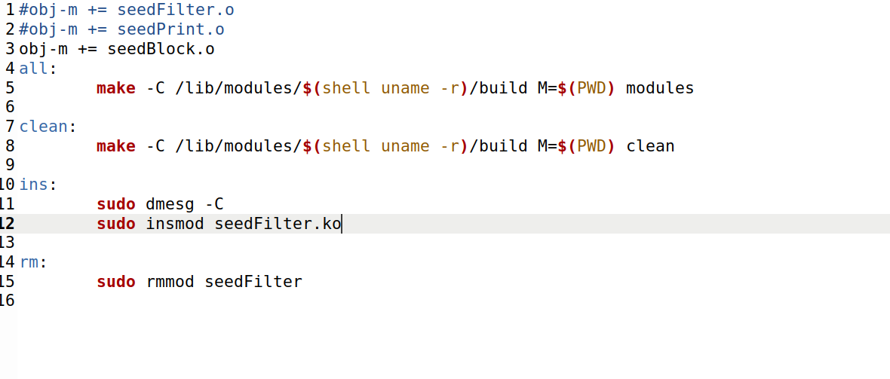

1. Compile and test network filtering.

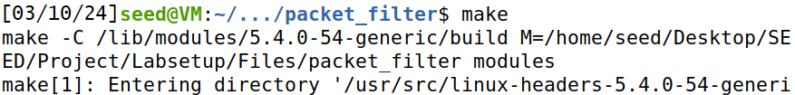

1. Upon execution of the file the module started as shown below.



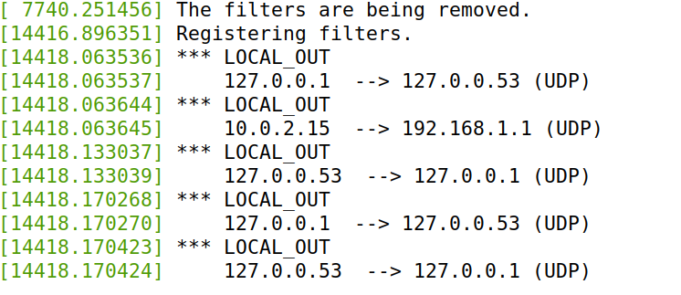

1. Now we try to ping and telnet from host A to seed vm and we can see that all traffic is dropped in both cases.

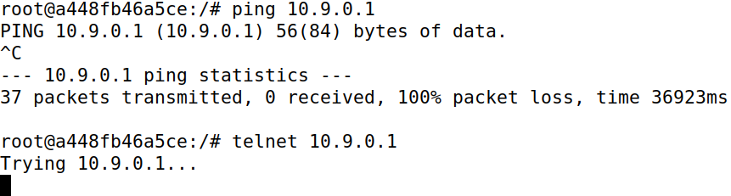

For ping;

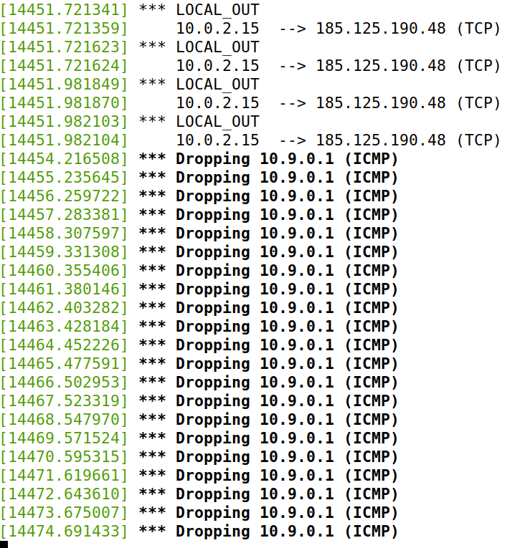

For telnet;

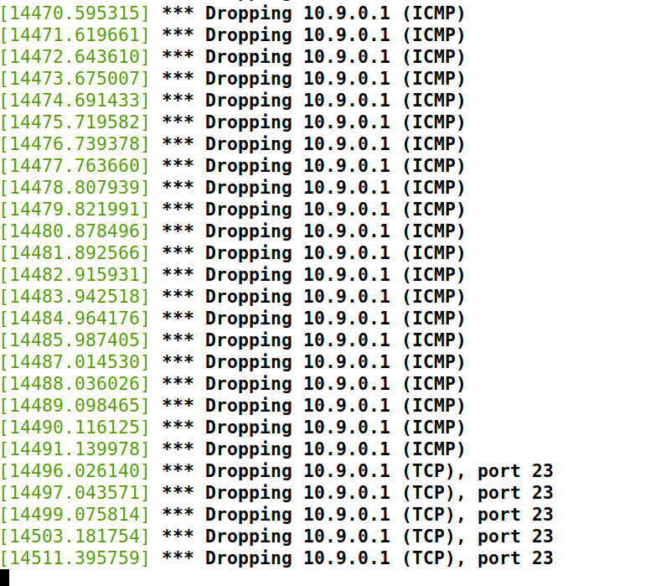

Task 2: Configuring IP Tables

Task 2 describes configuring IP Tables, a critical component of network security and routing. Subtasks include setting up IP Tables for the seed router (Task 2.A), defining specific rules for communication between hosts (Task 2.B), and ensuring proper communication channels between internal and external hosts (Task 2.C) is included.

## Task 2.A: Seed router IP Tables:

1. Configure the seed router IP Tables so that the telnet connection is blocked.

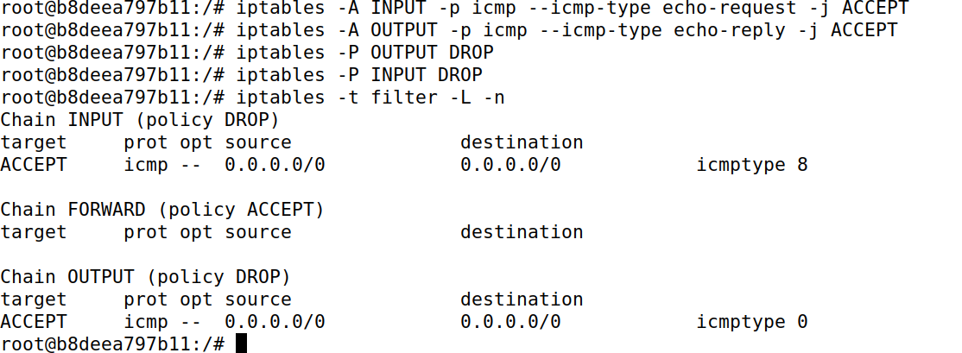

1. Now we try to ping and Telnet it to check if we established what was required.

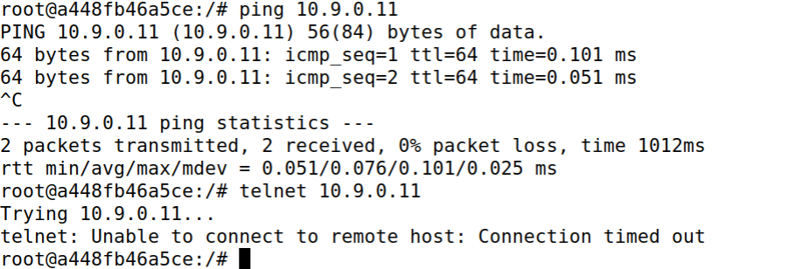

We can see that tenet connection is blocked.

1. Now we clear the ip tables.

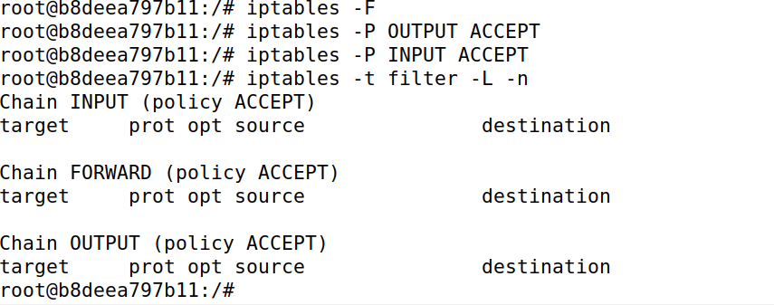

## Task 2.B: Internal network protection:

1. Configure rules for the seed router IP Table so that the router can only be pinged. On forming the telnet connection it should deny it.

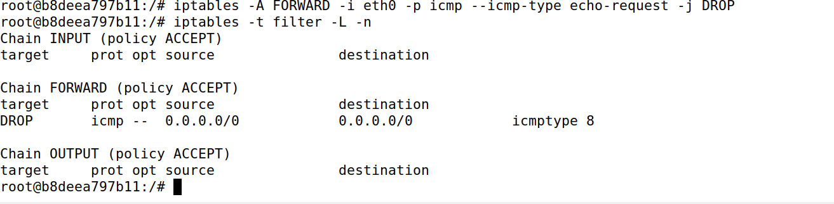

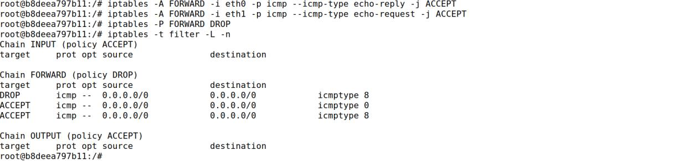

1. Test ping and Telnet connectivity from host A to internal hosts.

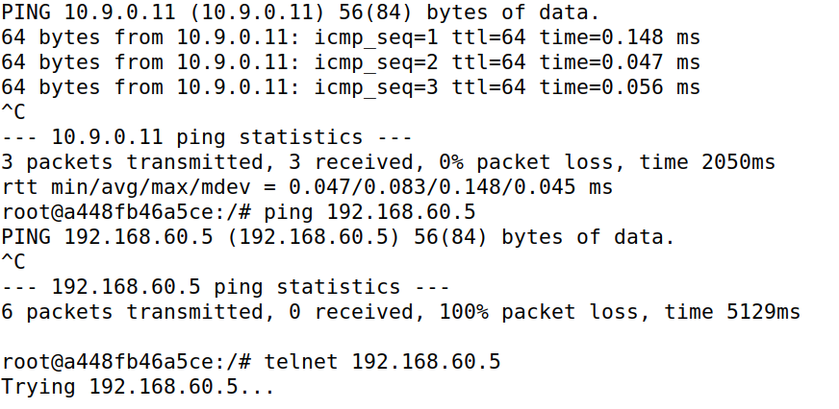

Here we can see that router can be pinged but when we try to telnet to inner host then it does not allow it.

1. Now we try to ping and telnet to host a from inner host.

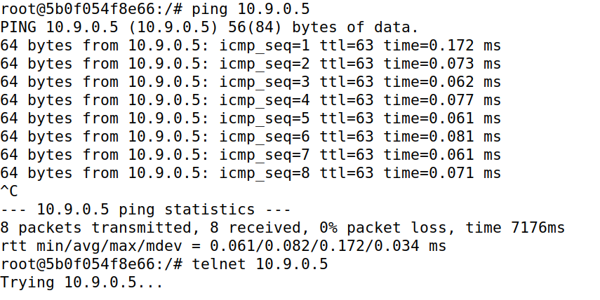

As we can see ping will work but on telnet again the connection is denied.

1. Now we will clean the ip tables.

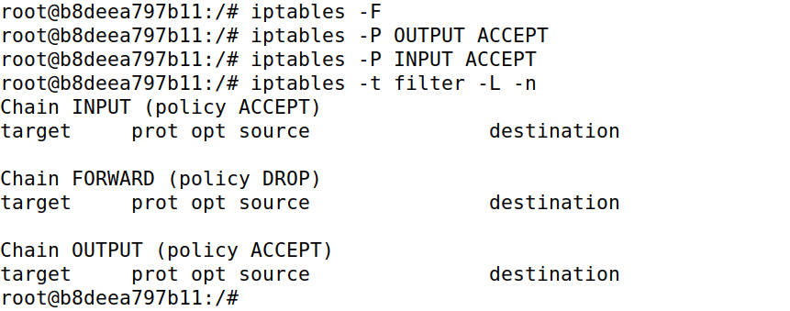

## Task 2.C: Internal Host Communication:

1. We will configure the iptables so that only 192.168.60.5 traffic is accepted.

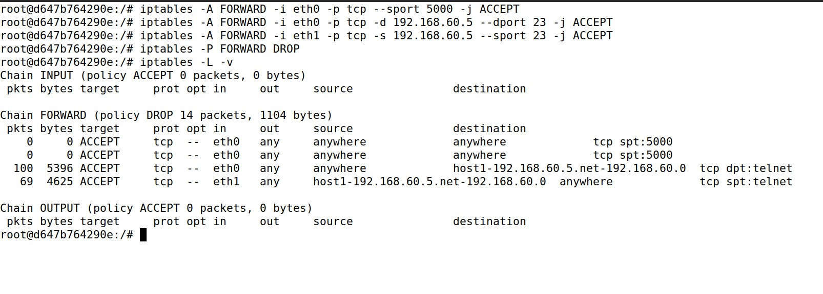

1. Now we test the connections to see if they were successful.

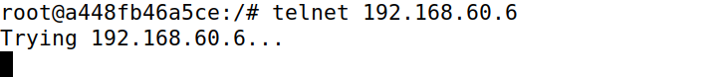

Here we can see that host A cannot telnet to internal host.

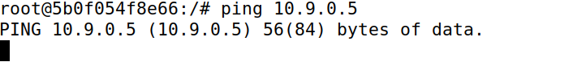

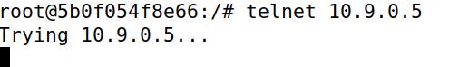

Here we can see that internal host cannot be able to make the connection.

1. Now we check connection of the internal hosts

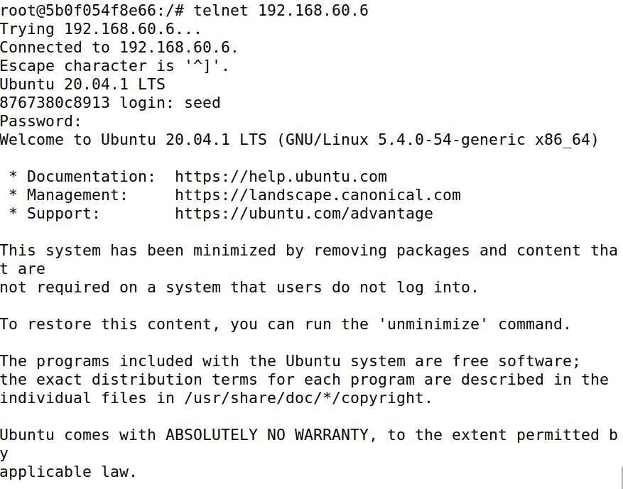

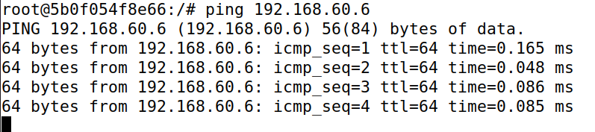

Here we can see that internal host can ping and telnet to each other

# Task 3: Experiments

Task 3 presents a series of experiments to analyze the behavior of ICMP, UDP, and TCP connections. Sub task 3.A requires you to conduct an experiment and record the connection duration. Sub task 3.B, on the other hand, focuses on configuring IPTables to control specific connection types.

## Task 3.A: ICMP, UDP, and TCP Experiments:

1. Conduct ICMP experiment.

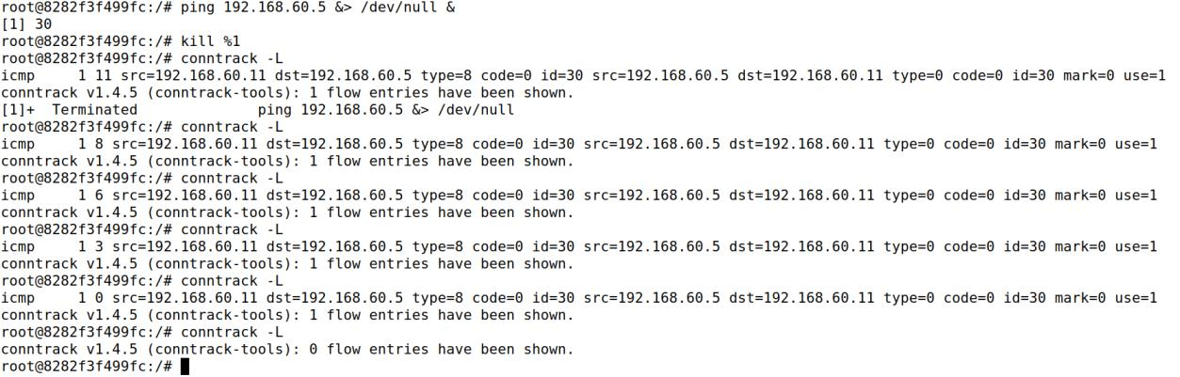

For ICMP we can see conntrack only working for 5 to 6 seconds.

1. Conduct UDP experiment. On host 1 open port 9090 for netcat UDP server.

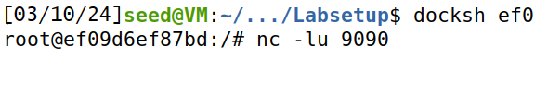

On host A we can see the connection as following

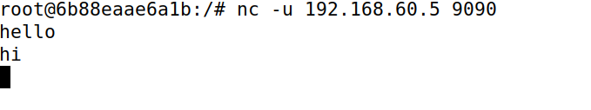

For UDP connection we can see that the conntrack remained for 8 to 13 seconds.

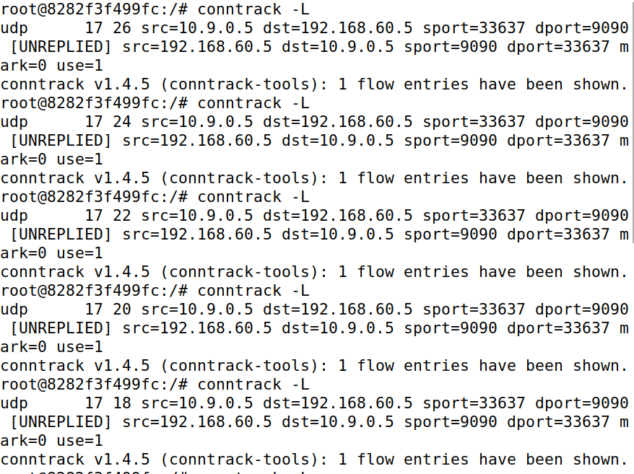

1. For TCP, we use netcat on port 9090 on host 1

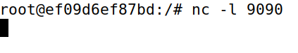

Then we send the following commands through host A to complete the connection.

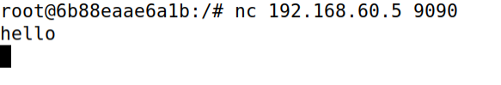

Now we used conntrack and we saw that the connection was working as long as possible.

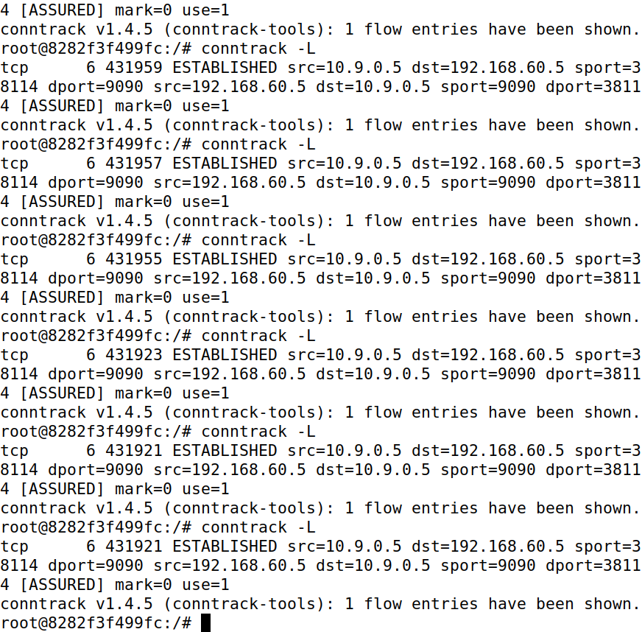

## Task 3.B: Configure IPTables:

1. Configure IPTables on the router for a specific connection.

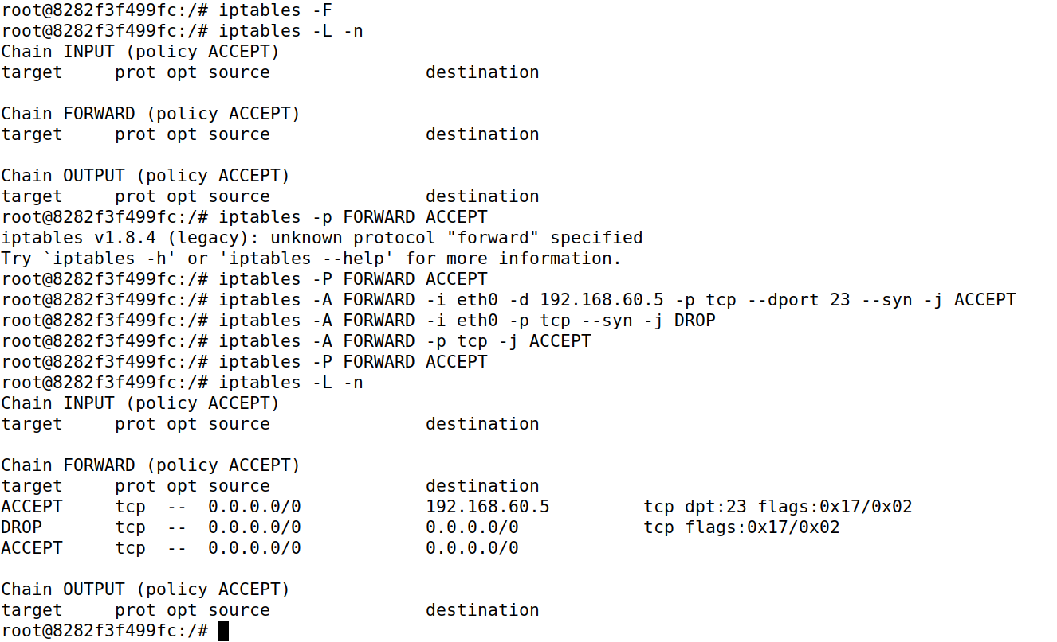

1. Test Telnet and Ping connectivity based on configured rules.

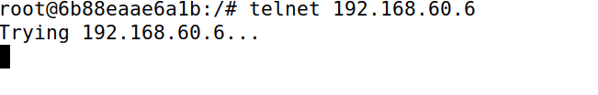

On telnet from host A to host 2 it was not allowed as shown above.

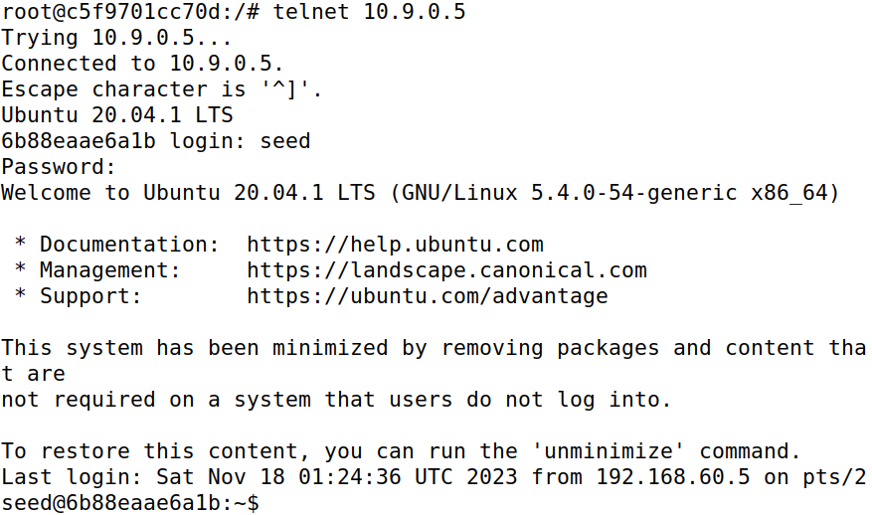

On telnet from host 2 to host A it is allowed as seen above.

1. Now flush the tables again.

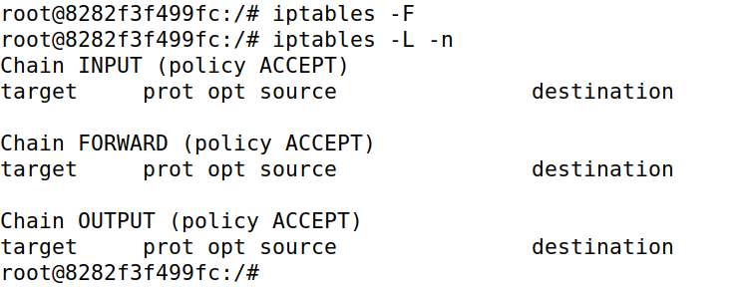

# Task 4: Traffic Limiting

Task 4 is to implement traffic limiting rules on the router. By configuring specific rules, the goal is to effectively monitor and control network traffic and ensure optimal network performance.

1. Configure rules to limit network traffic on the router.

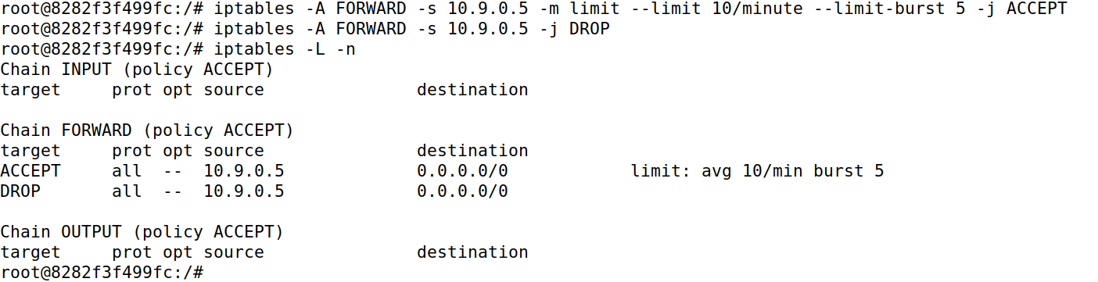

1. Test and observe the effectiveness of configured rules.

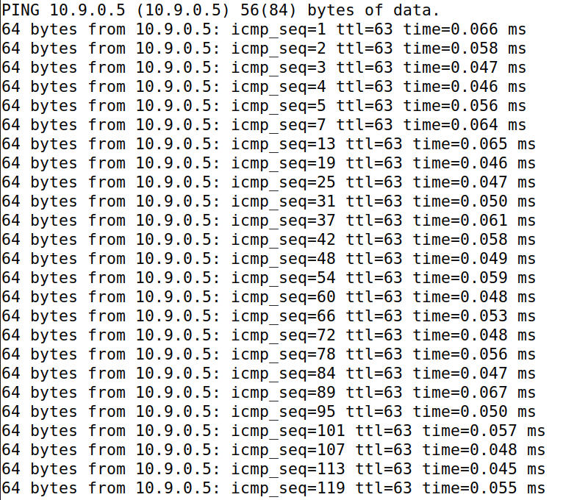

I tried with the first rule, but it didn’t seem to limit the packets but after placing the second rule it started to limit the network traffic from outside Host A.

1. Now we flush the ip tables

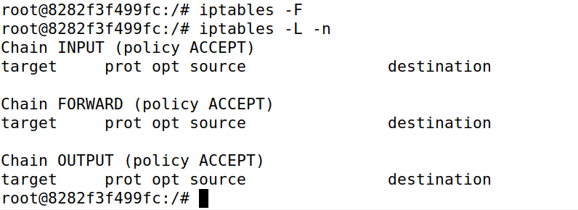

# Task 5: Load Balancing

The final task involves load balancing to evenly distribute network traffic across multiple internal hosts. This involves running commands on internal hosts and configuring routers to balance incoming packets, resulting in a more efficient and balanced network infrastructure.

1. Configure the router





1. Run the command on all three of the internal host.



1. Send the following packet from host A,

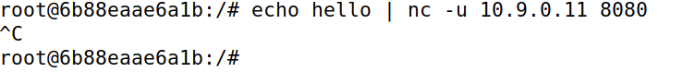

1. Now we see on the internal hosts as following,

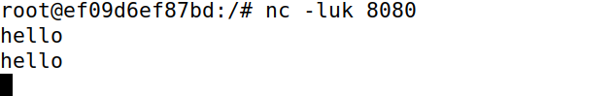



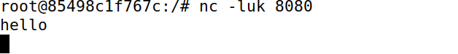

I found that each time a packet is sent it is sent to another internal Host which makes load balancing till here a success. So it can be said that if I only put uc -c 10.9.0.11 8080 and not used echo, I would receive packets in only in one of the internal Hosts but when I put delay in typing and entering then I receive packets in all the internal Hosts.

1. Now we add more rules to the router for proper configuration of load balancing.

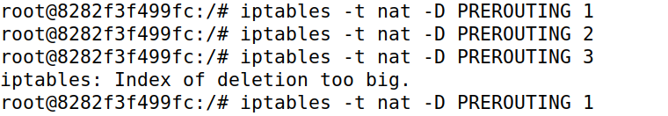

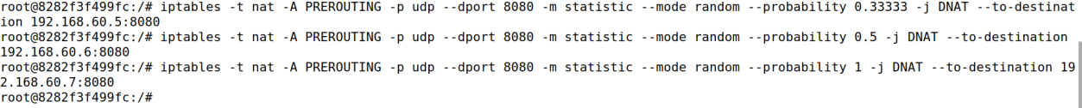

1. Now we again send the packets from host A as follows

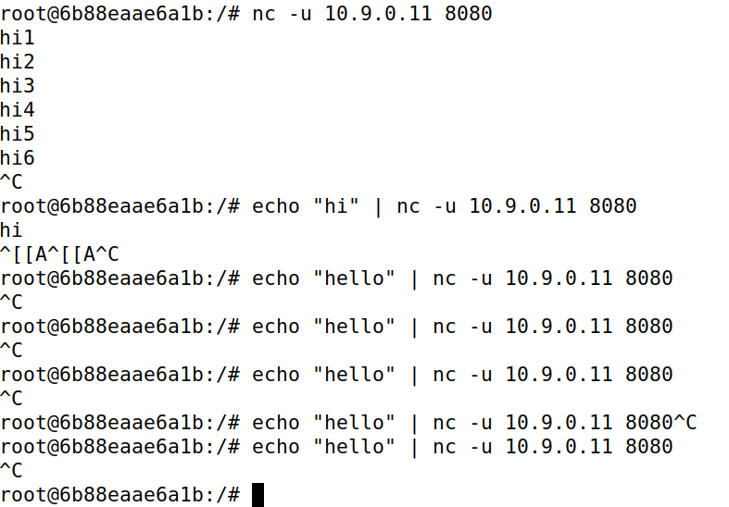

1. The packets received by all hosts are as follows,

Host 1,

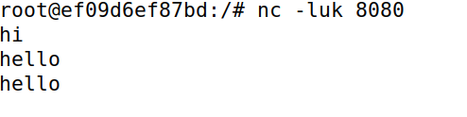

Host 2,

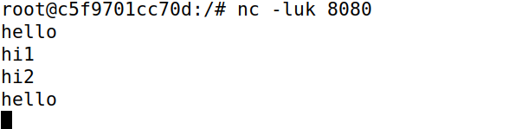

Host 3,

